

**Project Id: 2023CSEAIB019**

**Project Synopsis on**

**Vehicle Security Application Using RFID**

**Submitted in Partial Fulfilment of the requirement**

## For the Degree of

## Bachelor of Technology

**In**

**Computer Science and Engineering (AI)**

**By**

Pushpak Goel (2202901520128)

Pulkit Gahlot (2202901520127)

Prachi Pandey (2202901520118)

**Under the Supervision of**

## Dr. Vineet Kumar Singh

Assistant Professor

Department of Computer Science Engineering-AI

**ABES INSTITUTE OF TECHNOLOGY, GHAZIABAD**

AFFILIATED TO



**Dr A.P.J. ABDUL KALAM TECHNICAL UNIVERSITY, UTTAR PRADESH,**

## LUCKNOW

## (ODD SEM, 2023-24)

**Contents**

|  |  |  |
| --- | --- | --- |
| **Chapter no.** | **Contents** | **Page no.** |
| 1 | Abstract | 3 |
| 2 | Introduction | 4 |
| 3 | Literature Survey | 5 |
| 4 | Problem Statement | 6 |
| 5 | Proposed Methodology | 7 |
| 6 | Implementation and Result | 11 |
| 7 | Conclusion | 12 |
| 8 | References | 13 |

# Abstract

This project presents the development of a comprehensive vehicle security system that combines Arduino microcontroller technology, RFID authentication, and Flutter mobile application integration. The system aims to enhance vehicle security by enabling remote monitoring and control of lock/unlock stages. The Arduino microcontroller, equipped with an RFID reader and connected to a relay module and solenoid lock, manages the authentication process and controls the locking mechanism. The system incorporates a secure web application backend, built with Node.js, to facilitate communication between the Arduino and the mobile application. A Flutter-based mobile application provides users with real-time monitoring of the vehicle status and the ability to remotely lock or unlock the vehicle. Security measures, including encrypted communication and token-based authentication, are implemented to safeguard user data and system integrity. The proposed solution integrates IoT principles, offering a versatile and user-friendly approach to vehicle security, leveraging the capabilities of Arduino and Flutter technologies.

# Introduction

In the rapidly evolving landscape of smart technologies, ensuring the security of valuable assets such as vehicles has become a paramount concern. This project introduces a sophisticated vehicle security system that integrates the power of Arduino microcontroller technology, Radio-Frequency Identification (RFID) authentication, and Flutter-based mobile application development. The objective is to provide a robust and user-friendly solution remote monitoring and control of the vehicle's lock/unlock stages, enhancing security measures.

At the heart of this system is an Arduino microcontroller equipped with an RFID reader, a relay module, and a solenoid lock. The RFID authentication process allows for secure user identification, and the relay module, in conjunction with the solenoid lock, serves as the electronic counterpart to the traditional vehicle locking mechanism. The microcontroller is designed to communicate with a web application backend, built on Node.js, ensuring a seamless connection between the vehicle and the digital infrastructure.

The Flutter mobile application serves as the user interface, offering real-time monitoring capabilities and remote-control functionalities. Users can securely authenticate themselves through RFID tags and execute commands to lock or unlock the vehicle with the convenience of their mobile devices. To fortify the system against potential security threats, encryption protocols and token-based authentication mechanisms are implemented.

This amalgamation of hardware and software technologies not only addresses the imperative of vehicle security but also aligns with the principles of the Internet of Things (IoT). The proposed system signifies a step forward in providing a comprehensive and adaptable solution to modernize vehicle security, leveraging the strengths of Arduino microcontrollers and Flutter frameworks.

**Literature Survey**

|  |  |  |  |  |
| --- | --- | --- | --- | --- |
| **Paper Title** | **Year** | **Summary** | **Advantages** | **Disadvantages** |
| **Tracking Real Time Vehicle and Locking System Using**  **Lab view**  **Applications** | [2020](https://ieeexplore.ieee.org/xpl/conhome/9058619/proceeding) | This paper presents a model for portable embedded system to avoid burglary on vehicles. The complete prototype is designed on a single chip which is very simple and cost effective. Our proposed prototype compressed of a 32-bit microcontroller, SIM900A GPS/GSM Module, sensors and transducers. | An android based mobile application is developed in order to track the movement of vehicles even though the key ignition were  ON/OFF state. | Lacks detailed information on specific input features. Limited information on the dataset and data preprocessing steps. |
| **Vehicle**  **Tracking and**  **Locking System**  **Based on**  **GSM and**  **GPS** | 2013 | The safe of Vehicles is extremely essential for public vehicles. Vehicle tracking and locking system installed in the vehicle, to track the place and locking engine motor. The place of the vehicle identified using Global Positioning system (GPS) and Global system mobile communication (GSM). | Single supply voltage 3.2v-4.5v. Typical power consumption in SLEEP Mode: 2.5mA. SIM300 tri-band | Lacks specific technical details and case studies. |

# Problem Statement

The project addresses the pressing need for an advanced vehicle security system. This system aims to integrate cutting-edge technologies, specifically Arduino microcontroller technology, RFID authentication, and the Flutter mobile application framework, to create a comprehensive solution. The problem at hand is the absence of a modern, user-centric, and digitally connected security infrastructure that empowers vehicle owners with real-time monitoring and control capabilities.

The lack of an intelligent and interconnected security system not only poses a risk to vehicle owners but also contributes to the rising statistics of vehicle theft globally. This problem statement underscores the urgency for an innovative approach to vehicle security that combines hardware and software elements, incorporating IoT principles to fortify the protection of vehicles in today's dynamic and technologically advanced environment.

**Proposed Methodology**

**Hardware Setup:** Select Arduino Microcontroller Board: Choose an Arduino board with Wi-Fi capabilities, such as ESP8266 or ESP32, to facilitate internet connectivity. Integrate RFID Reader: Connect an RFID reader to the Arduino board to enable secure user authentication.

**Connect Solenoid Lock and Relay Module**: Wire the solenoid lock to a relay module, which is controlled by the Arduino to simulate the lock/unlock process.

**Arduino Code Development:** RFID Authentication: Develop Arduino firmware to authenticate users through RFID tags, validating against stored profiles.

**Lock /Unlock Control:** Implement code to control the relay module, managing the locking and unlocking of the solenoid lock.

**Wi-Fi Communication**: Establish secure communication between the Arduino and the server using Wi-Fi, incorporating encryption protocols for data security.

**Web Application Backend:**

Choose Backend Technology: Set up a backend server using Node.js with Express for its lightweight and efficient characteristics. API Development: Create APIs to receive RFID authentication status from the Arduino and send lock/unlock commands.

**Database Integration:**

Select Database System: Choose a suitable database system, such as SQLite or Firebase, to store user profiles, RFID tag information, and vehicle status.

Implement Database Operations: Develop functions to handle database operations, including user authentication and status updates.

**Flutter Mobile Application Development:** Install Flutter: Set up the Flutter framework for cross-platform mobile application development.

**Design User Interface (UI):** Create a user-friendly UI for the mobile application, incorporating features for monitoring vehicle status and controlling lock/unlock functions. Implement Authentication: Integrate

RFID-based user authentication within the Flutter app, ensuring secure access.

**Security Measures:** Encrypt Communication: Implement encryption protocols (e.g., HTTPS) for secure communication between the Arduino and the server.

**Token-Based Authentication**: Utilize token-based authentication for secure user sessions in the Flutter mobile application.

**Integration and Testing:** Establish Connectivity: Ensure a reliable connection between the Arduino, web server, and mobile application.

**Unit Testing:** Conduct thorough testing of individual components, including the Arduino code, server APIs, and Flutter app functionalities.

**Integration Testing:** Verify seamless integration between the hardware and software components.

**Deployment:** Cloud Hosting: Host the backend server and database on a secure cloud platform for scalability and reliability.

**Deploy Arduino in the Vehicle**: Install the Arduino microcontroller in the vehicle, ensuring a stable Wi-Fi connection for remote communication.

**Maintenance and Updates:** Regular Updates: Plan for regular updates to the system, addressing security vulnerabilities and introducing new features.

Monitoring: Implement monitoring mechanisms to track the system's performance and address any issues promptly.

**Work Flow Diagram**

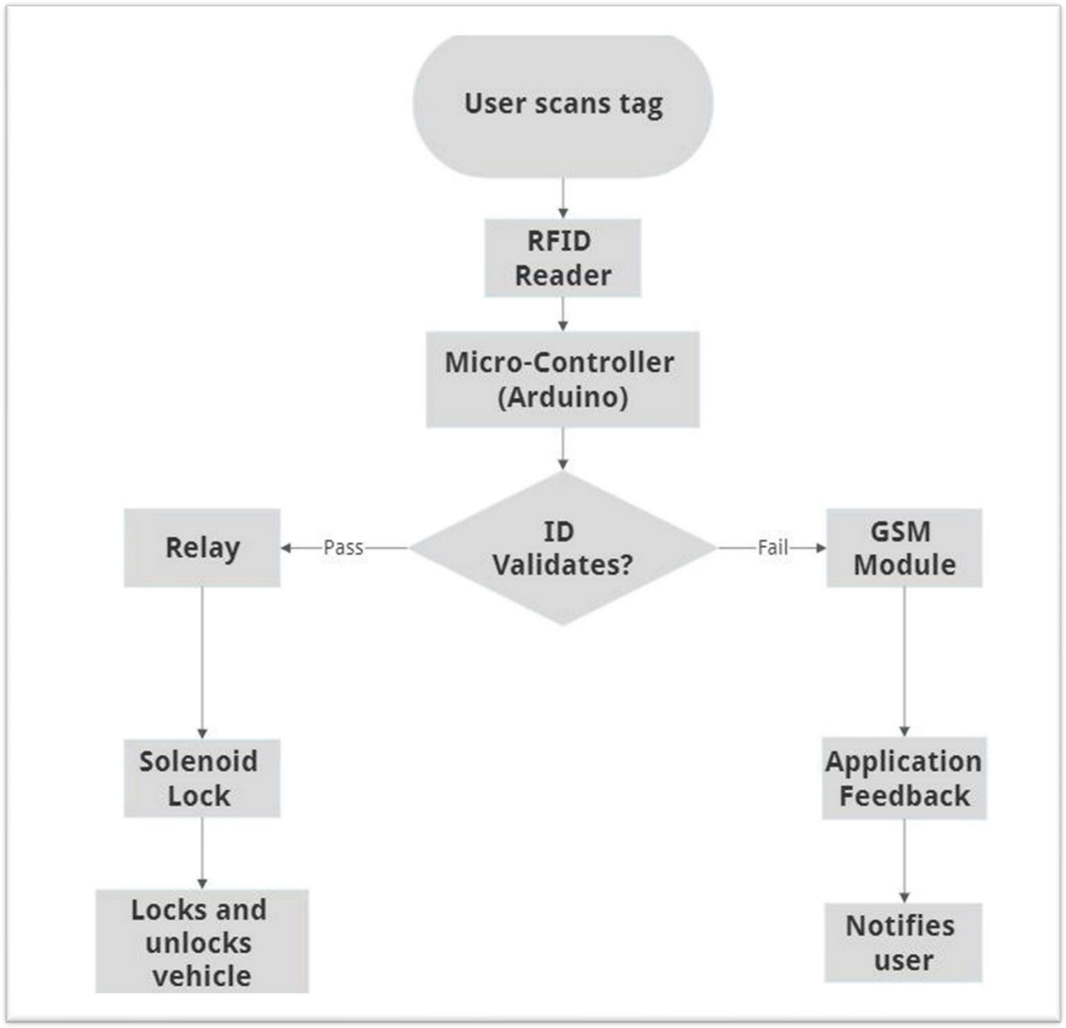

# Implementation And Result

**Implementation:**

**Execution of Activities:**

Conducted a community survey to assess the current condition of vehicle locks and their flaws.

Implemented awareness campaigns through workshops, posters, and social media to educate the community about the importance of smart locking system.

**Resource Management:**

Soured various equipment and parts through various marketplaces.

Allocated budget for purchasing of different parts that were required to build the prototype.

Researched various resources like research papers and others to gather the required data and information.

**Monitoring and Control:**

Implemented a feedback mechanism to address concerns and suggestions from community members.

Adjusted the project timeline and activities based on the evolving needs of the community.

**Results:**

**Achievement of Objectives:**

Built a working prototype within the first six months.

**Deliverables:**

Established a fully functional locking/unlocking system that can be controlled

remotely.

**Lessons Learned:**

Learnt about the working/functioning of Arduino microprocessor, RFID tag and reader, digital lock and some other components.

Got the hands-on experience of working on Arduino uno board and RFID tag and reader.

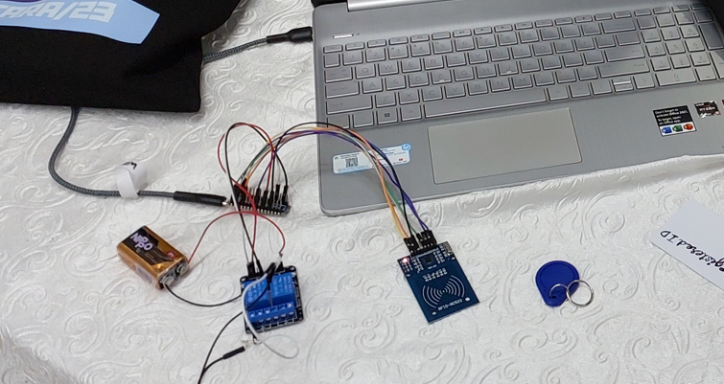Learnt about the importance integration of different components in project building. Documented successful strategies for replication in similar community projects.

**Conclusion**

In conclusion, the development of the advanced vehicle security system, combining Arduino microcontroller technology, RFID authentication, and Flutter mobile application integration, presents a promising solution to the challenges in modernizing vehicle security. The project was conceived to address the limitations of traditional locking mechanisms and the lack of real-time monitoring capabilities.

The integration of Arduino technology, serving as the brain of the system, allows for secure RFID-based user authentication and remote control of the vehicle's lock/unlock stages. Leveraging a web application backend built with Node.js and a Flutter-based mobile application, users gain unprecedented access to their vehicle's status and control functionalities, enhancing the overall security experience.

The proposed system not only addresses the immediate concerns of vehicle owners regarding theft and unauthorized access but also aligns with the principles of the Internet of Things (IoT). By establishing a secure and interconnected ecosystem, the project reflects a shift towards more intelligent and user-centric vehicle security solutions.

Throughout the development process, considerations for security were paramount. The implementation of encryption protocols, token-based authentication, and regular updates underscores a commitment to safeguarding user data and ensuring the system's resilience against potential threats.

As the project culminates, it becomes evident that the marriage of hardware and software technologies can usher in a new era of vehicle security. The proposed methodology, starting from the selection of components to deployment and maintenance, provides a systematic framework for creating a robust, adaptable, and user- friendly vehicle security system that aligns with the demands of the digital age. The strides made in this project contribute to the evolution of security systems, marking a significant step forward in the quest for safer and more intelligent transportation solutions.

# REFERENCES

1. I.J. Intelligent Systems and Applications, 2013, 09, 86-93

Published Online August 2013 in MECS ([http://www.mecs-press.org/)](http://www.mecs-press.org/) DOI: 10.5815/ijisa.2013.09.10

1. Tracking Real Time Vehicle And Locking System Using Lab view Applications

Published in: [2020 6th International Conference on Advanced Computing and Communication](https://ieeexplore.ieee.org/xpl/conhome/9058619/proceeding)

[Systems (ICACCS)](https://ieeexplore.ieee.org/xpl/conhome/9058619/proceeding) Date of Conference: 06-07 March 2020 Date Added to IEEE *Xplore*: 23 April 2020 INSPEC Accession Number:

19568536 DOI:

[10.1109/ICACCS48705.2020.9074323](https://doi.org/10.1109/ICACCS48705.2020.9074323) Publisher**:** IEEE

1. Canva.com
2. IEEEResearch.com
3. ResearchGate.com
4. Google.scholar.com

**Data Flow Diagram**

